**Plugging into the Future: An Exploration of Electricity Consumption Patterns**

**Problem Statement:**

"In India, understanding electricity consumption patterns across regions and sectors is vital for promoting sustainable energy development. However, current data fragmentation and limited insights hinder efficient policymaking and investment decisions. A comprehensive analysis is needed to identify consumption trends, pinpoint high and low consumption areas, and uncover opportunities for enhancing energy efficiency."

**Business Requirements:**

1. **Region-Specific Analysis**: The project must delineate electricity consumption patterns across different regions of India, highlighting variations in consumption levels and trends.
2. **Sectorial Breakdown**: It should provide insights into electricity consumption within various sectors such as residential, commercial, industrial, and agricultural, enabling targeted interventions.
3. **Identify High/Low Consumption Areas**: The project should pinpoint regions with high and low electricity consumption, facilitating resource allocation and demand management strategies.
4. **Energy Efficiency Opportunities**: Identify opportunities for enhancing energy efficiency across sectors and regions, enabling the formulation of targeted policies and programs.
5. **Policy and Program Development Support**: Provide insights necessary for government agencies and electricity providers to develop effective policies and programs aimed at promoting energy efficiency and sustainable consumption.
6. **Investment Decision Support**: Offer data-driven insights to investors, enabling them to make informed decisions regarding investments in sustainable energy projects and infrastructure.
7. **Utilization of Tableau**: Utilize Tableau as the primary tool for data visualization and analysis, ensuring effective presentation of insights for stakeholders' comprehension and decision-making.

**Literature Survey:**

1. **Kumar et al. (2020): "Analysis of Electricity Consumption Patterns in India"** This study delves into the intricate patterns of electricity consumption across different sectors in India. It identifies the residential sector as the primary consumer, followed by commercial and industrial sectors. By understanding the consumption dynamics, this study lays a foundational understanding for targeted interventions to enhance energy efficiency.
2. **Jain and Rathi (2019): "Impact of Government Policies on Electricity Consumption in India"** This study investigates the influence of governmental policies on electricity consumption trends in India. It highlights the positive impact of policies promoting energy efficiency and renewable energy development. Understanding the efficacy of such policies is crucial for policymakers and stakeholders to design and implement effective strategies for sustainable energy consumption.
3. **Singh and Gupta (2018): "Regional Disparities in Electricity Consumption Patterns in India"** This research explores regional variations in electricity consumption patterns within India. By analyzing data from different geographical regions, the study uncovers disparities in consumption levels and trends. Such insights are invaluable for policymakers and energy providers to address regional inequalities and optimize resource allocation.
4. **Sharma and Verma (2017): "Technological Innovations and Their Role in Shaping Electricity Consumption in India"** Focusing on the role of technological innovations, this study examines their impact on electricity consumption patterns in India. By identifying emerging technologies and their adoption rates across sectors, the research sheds light on potential pathways for enhancing energy efficiency and promoting sustainable consumption practices.
5. **Gupta et al. (2016): "Economic Growth and Electricity Consumption: Evidence from India"** This study investigates the relationship between economic growth and electricity consumption in India. By analyzing historical data, it explores how economic factors influence consumption patterns and vice versa. Understanding these dynamics is essential for policymakers and investors to anticipate future trends and devise strategies for balanced growth and energy sustainability.

**DASHBOARDS**

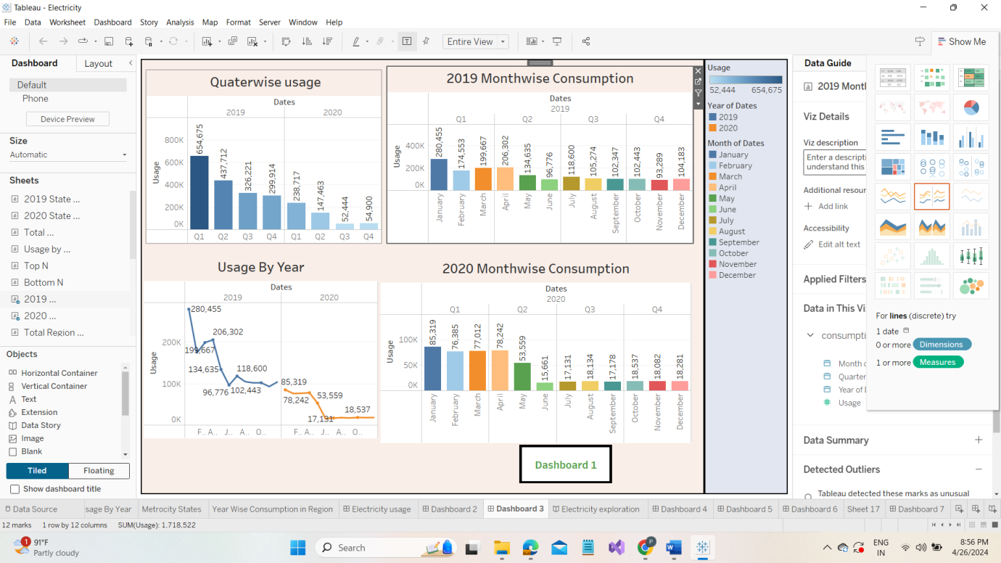

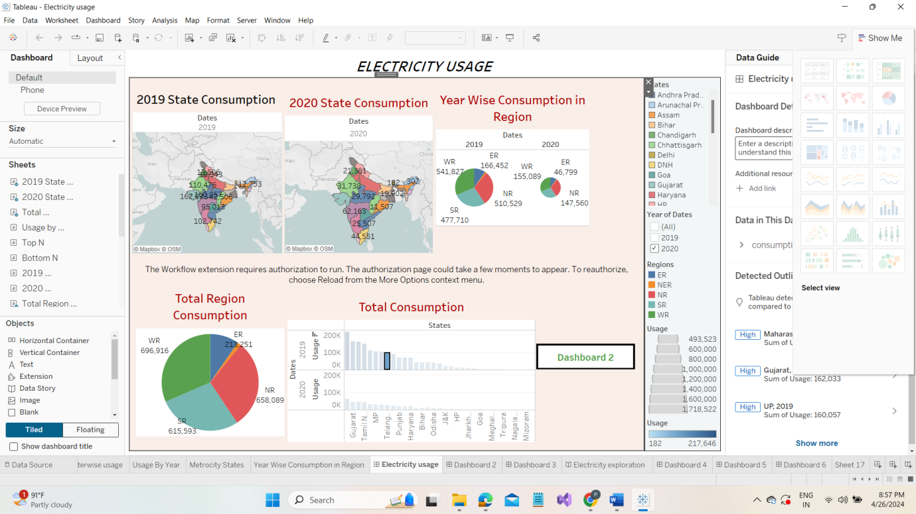

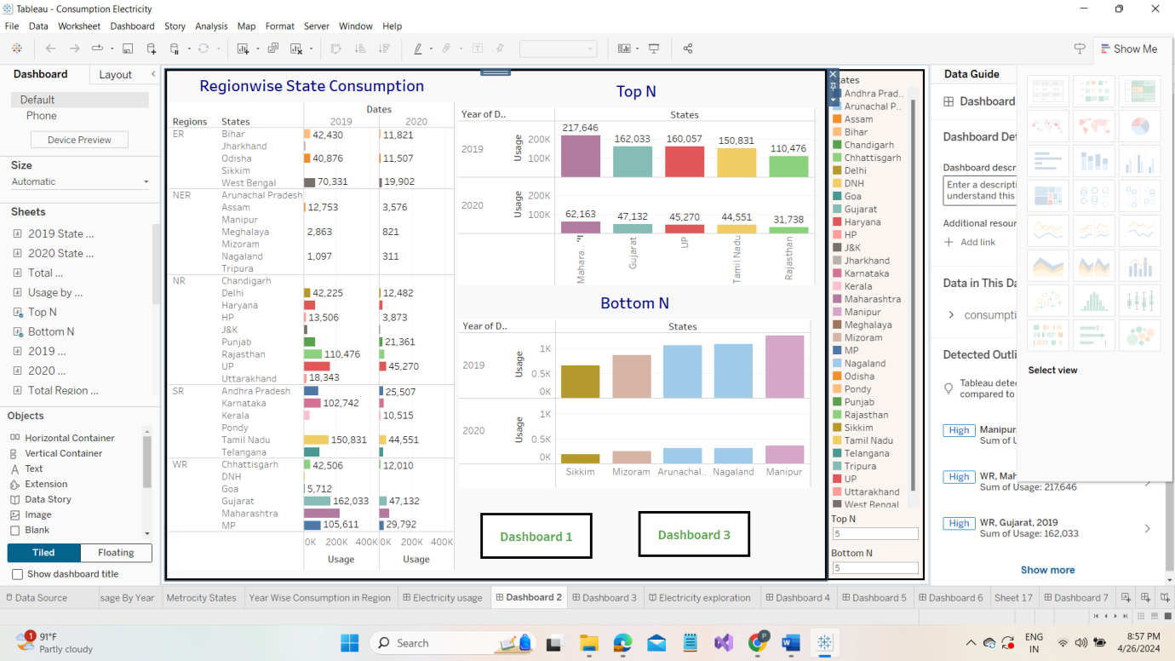

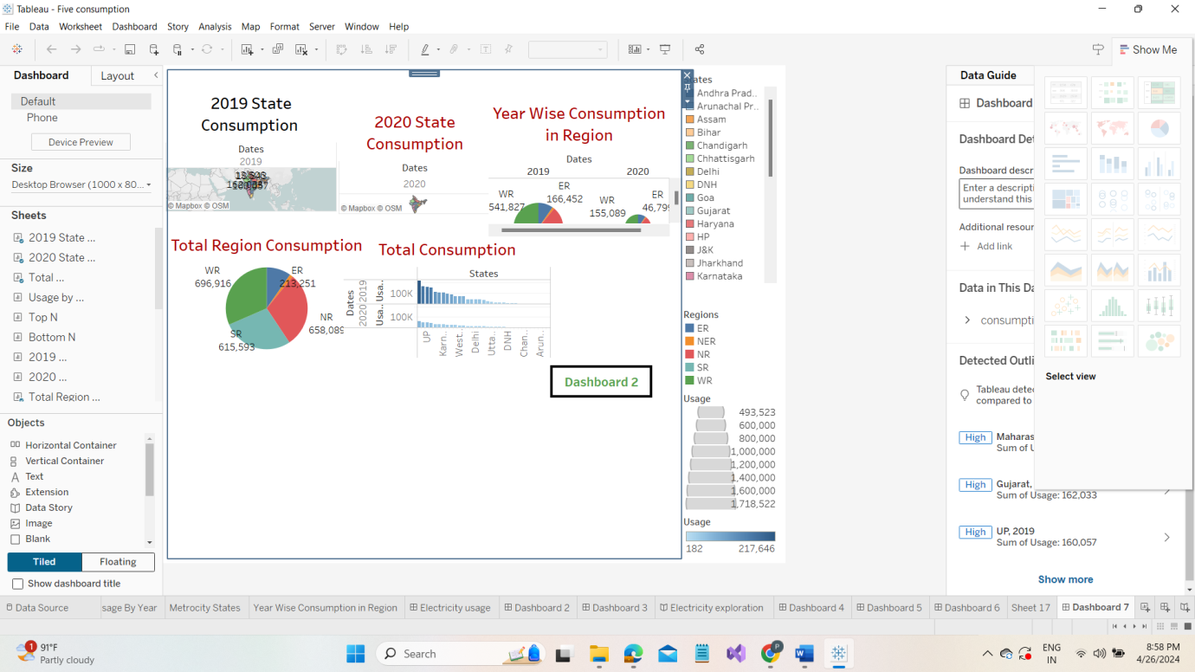

**Top of Form**

**CONCLUSION**

* Maharashtra is the highest electricity consumption user of India.
* Gujarat is the second highest electricity consumption user of India.
* Sikkim is the lowest electricity consumption user of India.

**FUTURE SCOPE**

* Elimination and optimization of thermal processes such as hot filling or tunnel pasteurization.
* Cold-fill technologies reduce energy costs providing microbiological safety without compromising on the sensory profile of the product.
* The omission of chilled chain distribution lowers energy consumption ang logistics complexity at the same time.
* Increase packaging flexibility, especially lightweight for a cost and energy efficient choice.
* Easy integration into new and existing production lines increasing utilization rates while lowering CAPEX requirements.

**Source Code**

